Activity 6: PHP REST Service
Samantha Krall
CST-236
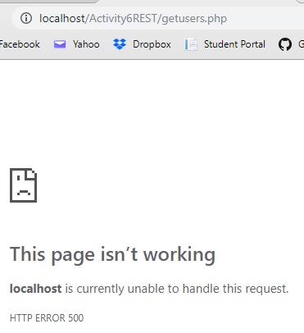
While REST stands for Representational State Transfer, which is an architectural style for networked hypermedia applications, it is primarily used to build Web services that are lightweight, maintainable, and scalable. A service based on REST is called a RESTful service. REST is not dependent on any protocol, but almost every RESTful service uses HTTP as its underlying protocol. The purpose of a service is to provide a window to its clients so that they can access these resources. In general, RESTful services should have these properties and features: Representations, messages, URIs, uniform interface, stateless, links between resources and caching.

References:
Vaqqas, M., & Vaqqas, M. (n.d.). RESTful Web Services: A Tutorial. Retrieved from http://www.drdobbs.com/web-development/restful-web-services-a-tutorial/240169069

